FAD Adult Child Reference Letter
Purpose: Use this form to gather information from the adult children of prospective or current foster and adoptive parents.
Directions: Provide this form to the adult children of prospective or current foster and adoptive parents. Make sure to delete the Purpose and Directions before printing out. If mailed, include a self-addressed postage paid envelope so the adult child can return form K-902-2195. This form can also be emailed or used during telephone interviews.

Name of Adult Child:

Name of Staff Sending Form:

FAMILY HISTORY

Describe your mom or stepmom's personality and temperament:

How does your mom or stepmom react to misbehavior in children?

Do you believe your mom or stepmom would be able to cooperate with the agency and accept supervision from a caseworker in caring for the child or children? Why or why not?

Describe your father or stepfather's personality and temperament:

How does your father or stepfather react to misbehavior in children?

Do you believe your father or stepfather would be able to cooperate with the agency and accept supervision from a caseworker in caring for the child or children? Why or why not?

If there are children currently in the home, how do your parents respond to misbehavior?

CHILDHOOD HISTORY

Did you grow up with your parents?
Yes No; If not, please explain:

Describe what type of parent your mom or stepmom was while you were growing up:

Describe what type of parent your father or stepfather was while you were growing up:

Do your parents have any history of instability (such as mental illness, drug or alcohol abuse, gambling addiction, relationship issues, and so on) that you are aware of? Yes No If yes, please explain:

Do your parents have any history of, or current, financial problems that you are aware of? Yes No If yes, please explain:

Were your parents abusive or neglectful to you or your siblings while growing up? Yes No; If yes, please explain:

How did your parents discipline you as a child?

How do your parents handle stress or crisis in their daily lives?

How often do you visit in the home of your parents?

How do you think fostering or adopting will affect your relationship with your parents?

Would you recommend your parents as foster or adoptive parents for a child who has suffered abuse and trauma? Why or why not?

ADDITIONAL INFORMATION

My parents do not have any health concerns that would affect their ability to parent a child or children full-time.
Yes No
My parents have the ability to take on extra responsibilities at this time. Yes No

My parents' work schedules are flexible enough for them to be able to meet the needs of the child or children placed in their home. Yes No

I believe both my parents are equally committed to fostering or adopting. Yes No

While growing up, I felt supported by my parents (they attended my extracurricular functions, came to school or church functions when I was preforming, provided emotional and financial support when needed, and so on). Yes No

Please add any additional information which you feel can help us make a good decision about placing a child or children with your parents.
Name of Person Completing form: | Date Completed:

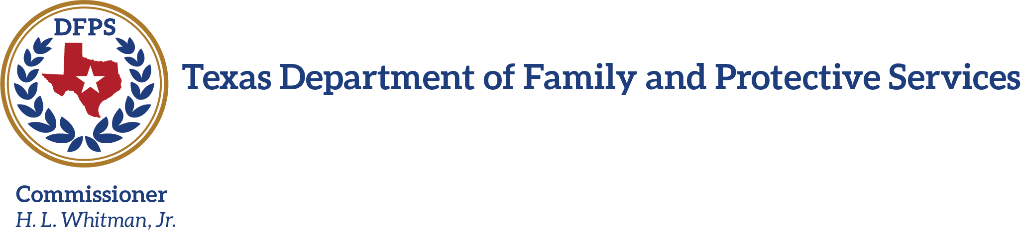

Dear ,

Your parents, , have applied to foster or adopt through our agency. One of our requirements to complete the home screening is to interview all adult children. Fostering or adopting children who have been abused and neglected requires knowledge, skills, and abilities beyond raising children of their own. We will use your comments to assist in determining if your parents will be able to manage the needs of this unique population of children and youth.

Please answer the questions in the attached form K-902-2195. This form can be completed electronically or manually. This form can be completed, scanned, and emailed. If scanning, please email this document back to: @dfps.state.tx.us. If completed manually, please return the form as quickly as possible to the office address listed below.

If you need additional space, please add extra sheets of paper.

If you have any questions, concerns, or prefer to respond by phone about your parents adopting or fostering, please do not hesitate to contact me at: .

We appreciate your willingness to share your honest thoughts of your parents with the Texas Department of Family and Protective Services.

Sincerely,

Caseworker Name

Office Address

701 W. 51st Street ♦ P. O. Box 149030 ♦ Austin, Texas 78714-9030 ♦ (512) 438-4800
K-902-2195 September 2015
An Equal Opportunity Employer and Provider

