
Certificate participation

Attendee
attended a support group with a Parent Representative.
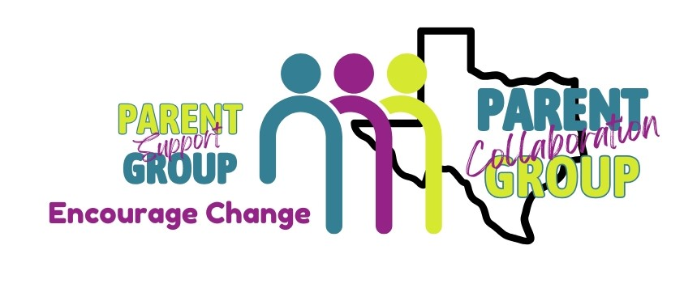
The goal of the group is to help parents gain a better understanding of the Child Protective Service system and receive guidance from a parent that has successfully navigated the child welfare system.
Parent Liaison
CPS Liaison
Date

