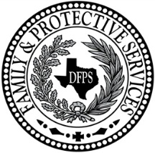
Permanency Conference Plan-Additional Child
Child Protective Services - Purchased Client Services

Purpose: This form is used by FGDM staff during a Permanency Conferences with families that have multiple children.
Directions: After completion, this form must be attached to the back of the completed Permanency Conference Plan (form 0628) and must be identified in Section L of the completed Permanency Conference Plan.
Staff: Refer to Form 0628ins, Instructions for Completing Permanency Conference Plan for directions, instructions, and help regarding this form

Section F: Child Well-Being & Permanency Status
Child Name: | Age: | Is the child in an Intended to be permanent placement?  Yes No
Needs/Concerns (include educational, medical, mental health, behavioral, therapeutic, developmental, dental, vision, hearing needs, etc.)

Services received or needed (ARD, ECI, therapy, medical/dental, vision, hearing, extra-curricular, medications to address identified needs; include progress/barriers):

Connections (identify individuals who are important to the child and what type of contact is allowed):

If child not in an intended permanent placement: Have all placement resources been explored? (Relative search, symbolic/fictive kin relatives, absent parents, home study/ICPC)

