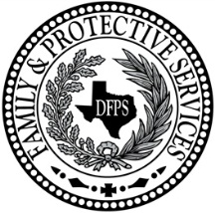
Evaluation & Treatment
Client Satisfaction Survey Questionnaire
Child Protective Services - Purchased Client Services
Date: |  |  | Facilitator:
Agency:

Put an X in the box for your answer to each question. If the question does not apply to you, mark the NA box for Not Applicable. | Strongly Agree | Agree | Disagree | Strongly Disagree | NA
1. My therapist believes that I can change and grow. My therapist helps me find my own solutions.
2. My therapist encourages me to be responsible for the safety of my kids. My therapist helped me find relatives and friends who care about the safety of my kids.
3. My therapist understands my problems and worries and makes me feel comfortable talking about my life and my family.
4. I learned new ways to parent my kids and I have been using my new skills at home.
5. I learned a lot about how kids grow and develop. I learned how abuse and neglect hurts kids and how it makes them act. I learned about my children's needs and how I can meet them.
6. I understand the problems that caused CPS to open a case and most of the problems are getting better.
7. My therapist encourages me to attend other classes or join other support groups or participate in community activities. I found other agencies or groups that could help me with my life and my kids.
8. My therapist is respectful of my culture and how we raise our kids.
9. If I had other choices, I would still get services from this therapist
10 This therapy made positive changes in my life and in how I parent my kids and I would tell someone to try this kind of therapy if they had problems like mine.

Comments (What did you like most about therapy? Like least? Is there anything you wanted that was not part of the therapy?)
Client Signature Date Signed

